After user presses on the Bookings from the Side Menu(from the hamburger button). It leads to this:

IT is missing the top menu with the hamburger button

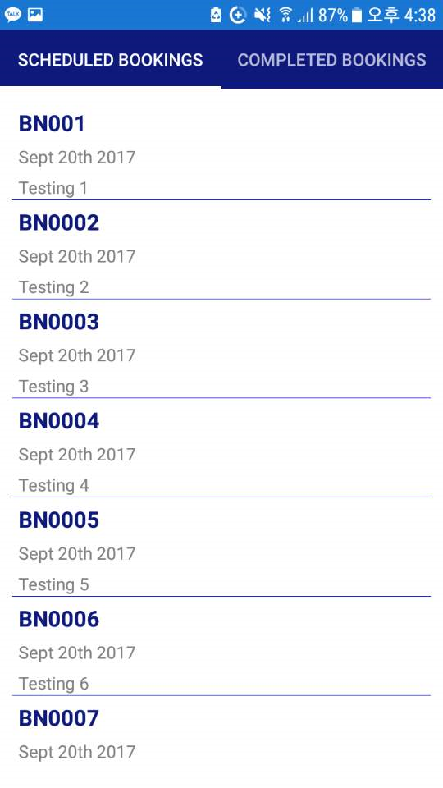

Rep: Have changed it. Please check and reply

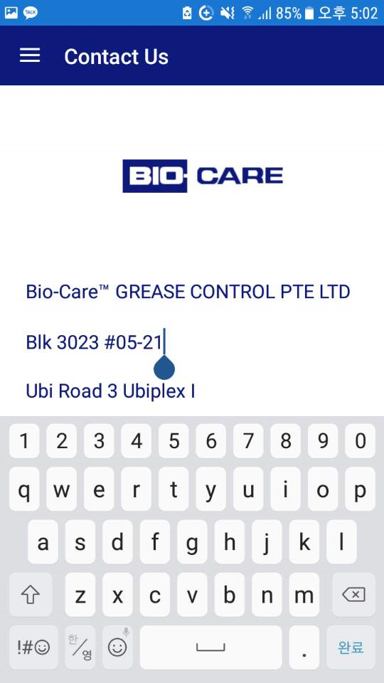

Make the keyboard not come up at all.

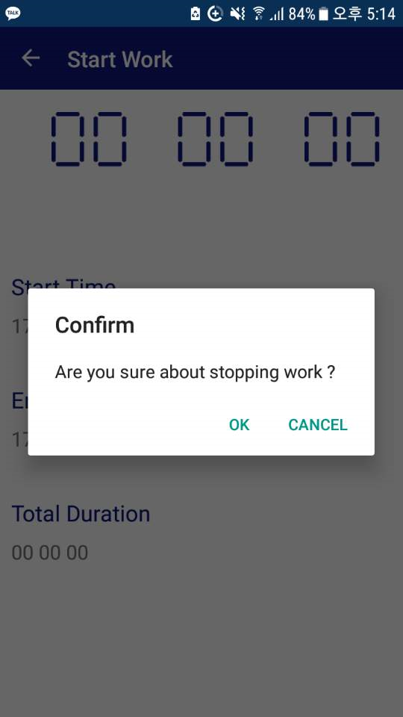

Replace “Are you sure about stopping work?” to “Are you sure you want to stop work?”